◈ What is a Firmware Library?
A firmware library is a set of ready-made functions that help control hardware easily.
Instead of writing difficult hardware code again and again, we use simple functions like:-
gpio_start()
gpio_on()
gpio_off()
These above functions do the hard work inside and make the program easy to write and understand.

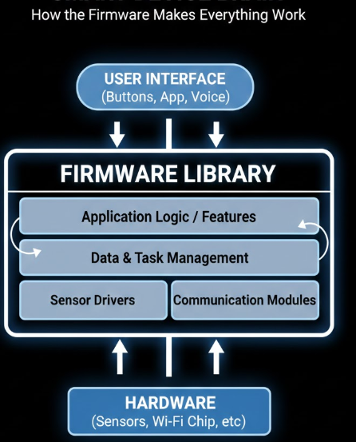
Why it is called a firmware library:
- It has code that actually works (gpio.c)
- It talks to or simulates the hardware
- It is used by application programs (main.c)

◈ Why APIs are Important in Embedded Systems?
An API (Application Programming Interface) is a set of functions or commands that lets a program communicate with hardware without needing to know the internal details of how the hardware works.
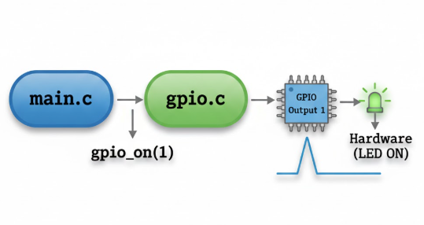
Consider the above scenario , By that one can say that We don’t need to know how the pin turns ON. The API handles it for us.
APIs are Important in Embedded Systems because:-
- Hardware abstraction: Hide low-level register details
- Code reusability: Use same API in multiple projects
- Faster development: Use ready-made functions
- Improved portability: Application works on different hardware
- Easier maintenance: Hardware changes affect only API

◈ What was understood from the lab code?
From the lab code, I understood that:
▪Firmware libraries let us control hardware easily using ready-made functions.
▪APIs hide the complex hardware details, so we can focus on writing simple commands.
▪Using functions like gpio_on() or gpio_off() makes code shorter, easier, and less error-prone.
▪The program flow is usually: Application → API → Firmware Library → Hardware.

◈Lab Code

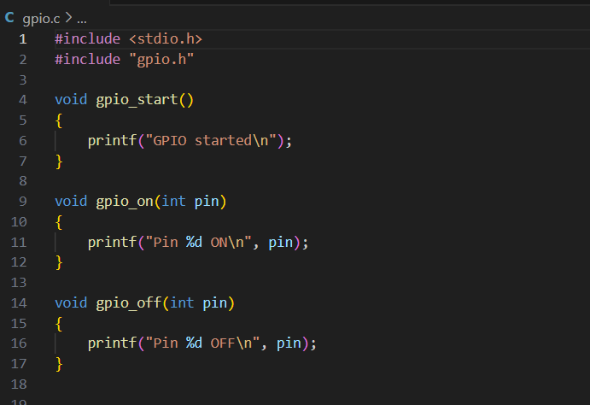
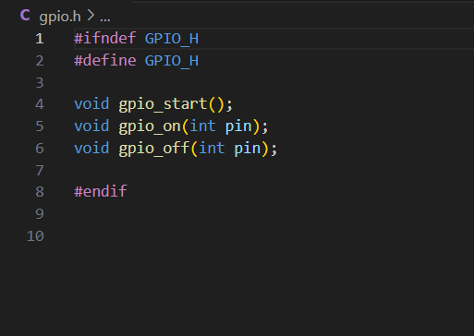

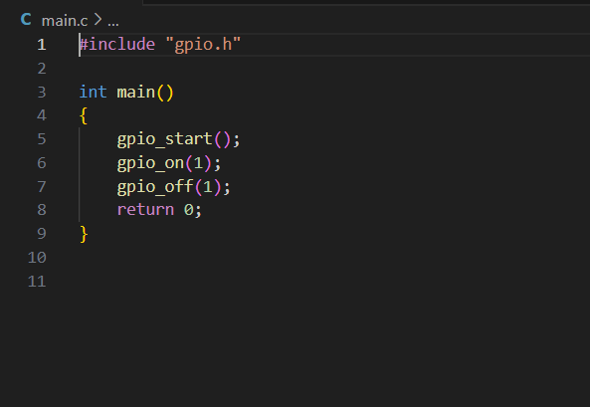

◈ Conclusion of the Lab:
- Modular Design: The code is split into three files to keep it organized and professional.
- The Header (gpio.h): Acts as a "menu" that tells the program which functions are available to use.
- The Logic (gpio.c): Contains the actual "instructions" for how the GPIO functions work.
- The Application (main.c): Uses the functions to perform a specific task, like turning a pin on and off.
- Header Guards: The #ifndef lines prevent the code from being loaded twice, which avoids errors.
- Hardware Abstraction: main.c doesn't care how the pin turns on; it just calls the function to do it.

◈ Code Output:

